VPC Task-10
AWS VPC and EC2 Infrastructure Setup
Configuration of Public/Private Subnets, NAT Gateway, Apache Tomcat, PHP, and VPC Flow Logs using CloudWatch and S3

1.Create VPC with 2 private and 2 public subnets.

Steps:
- Open AWS Console → Go to VPC Dashboard → Create VPC.
- Enter VPC name and IPv4 CIDR block (example: 10.0.0.0/16).
- Create 2 public subnets with different CIDRs and Availability Zones.
- Create 2 private subnets with different CIDRs and Availability Zones.
- Attach an Internet Gateway and associate public subnets with a public route table.

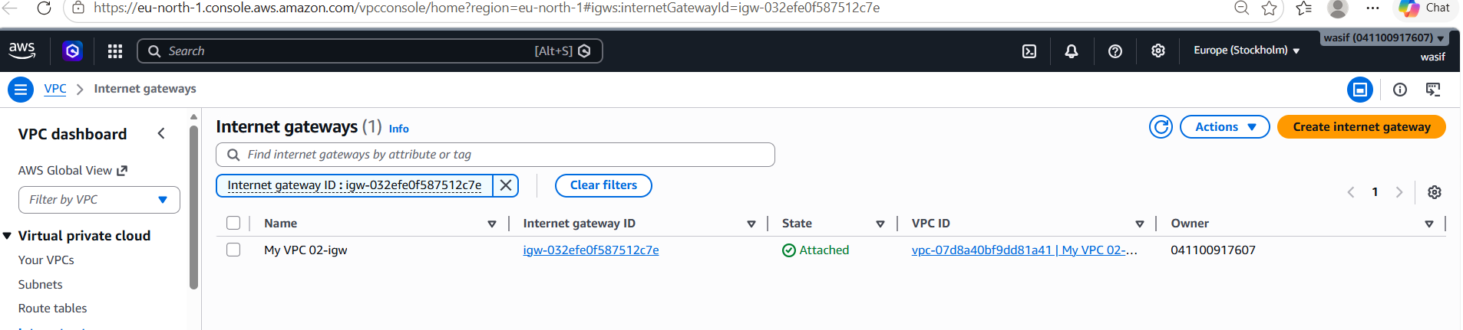

2 Enable DNS Hostname in VPC.

Steps:
- Open AWS Console → Go to VPC Dashboard.
- Select your required VPC from Your VPCs.
- Click Actions → Edit VPC settings.
- Enable DNS Hostnames and DNS Resolution.
- Click Save changes to apply the settings.

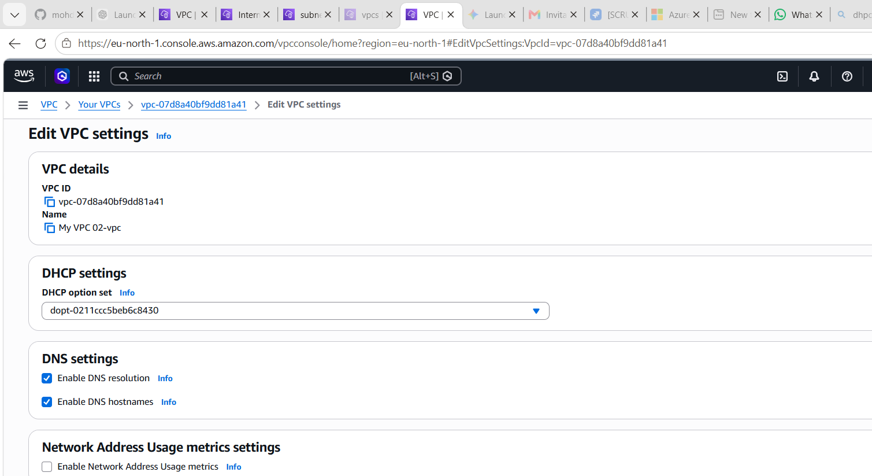

3 Enable Auto Assign Public IP in 2 public subnets
Steps:
- Open AWS Console → Go to VPC Dashboard → Subnets.
- Select the first public subnet.
- Click Actions → Edit subnet settings.
- Enable Auto-assign public IPv4 address and save changes.
- Repeat the same steps for the second public subnet.
!st Public Subnet
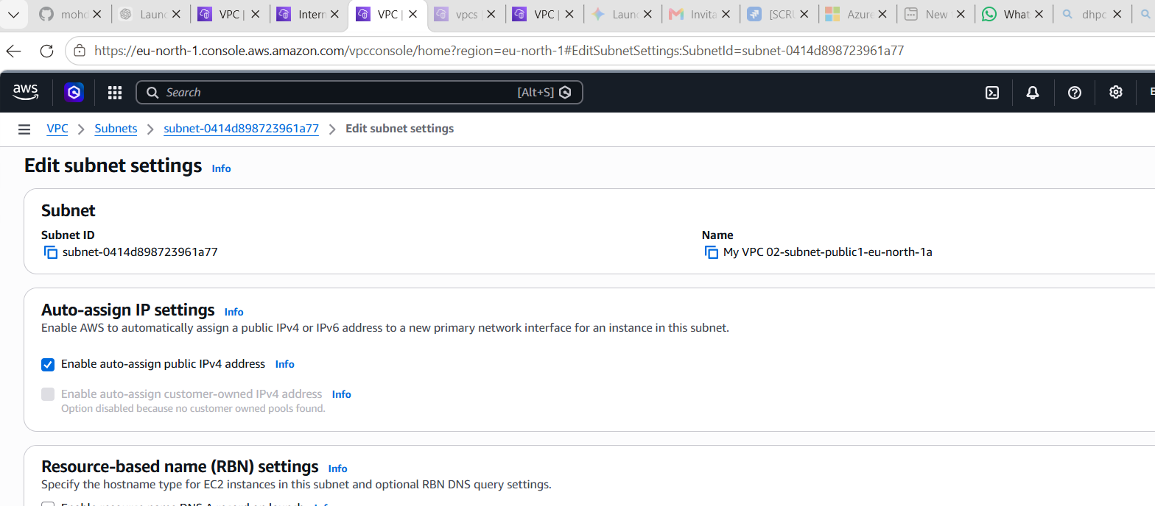

2nd Public subnet
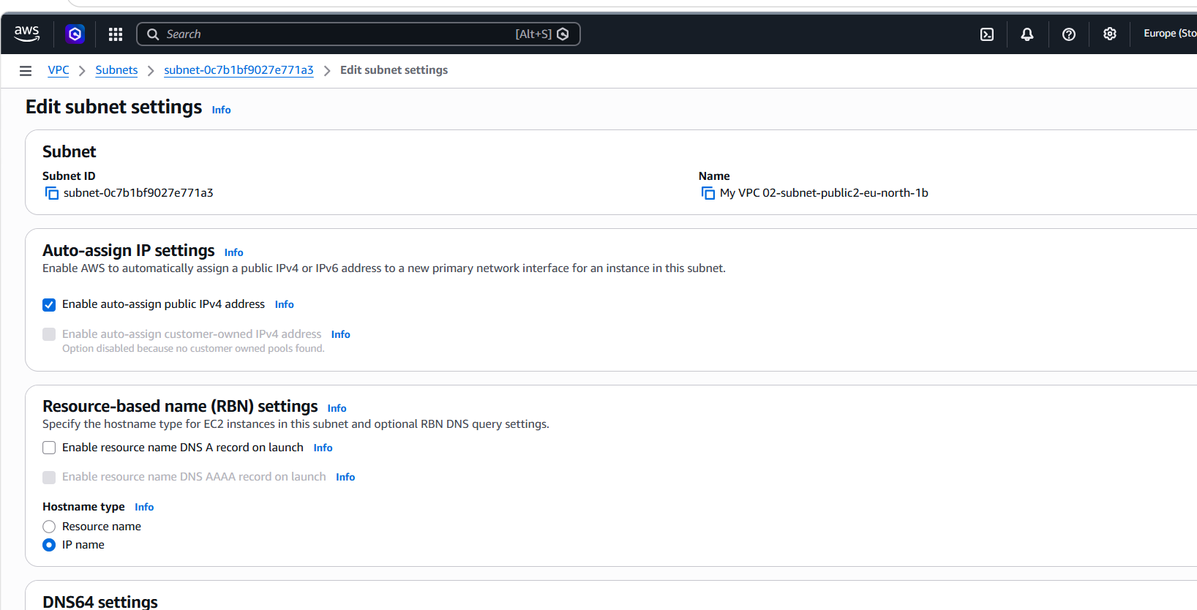

4 Add 2 private subnets in private route table.

step lines to add 2 private subnets to a private route table in AWS:
- Open AWS Management Console → go to VPC service.
- In the left menu, click Route Tables.
- Select your Private Route Table (the one created for private subnets).
- Go to the Subnet Associations tab.
- Click Edit subnet associations.
- Select your Private Subnet 1 and Private Subnet 2.
- Click Save associations.
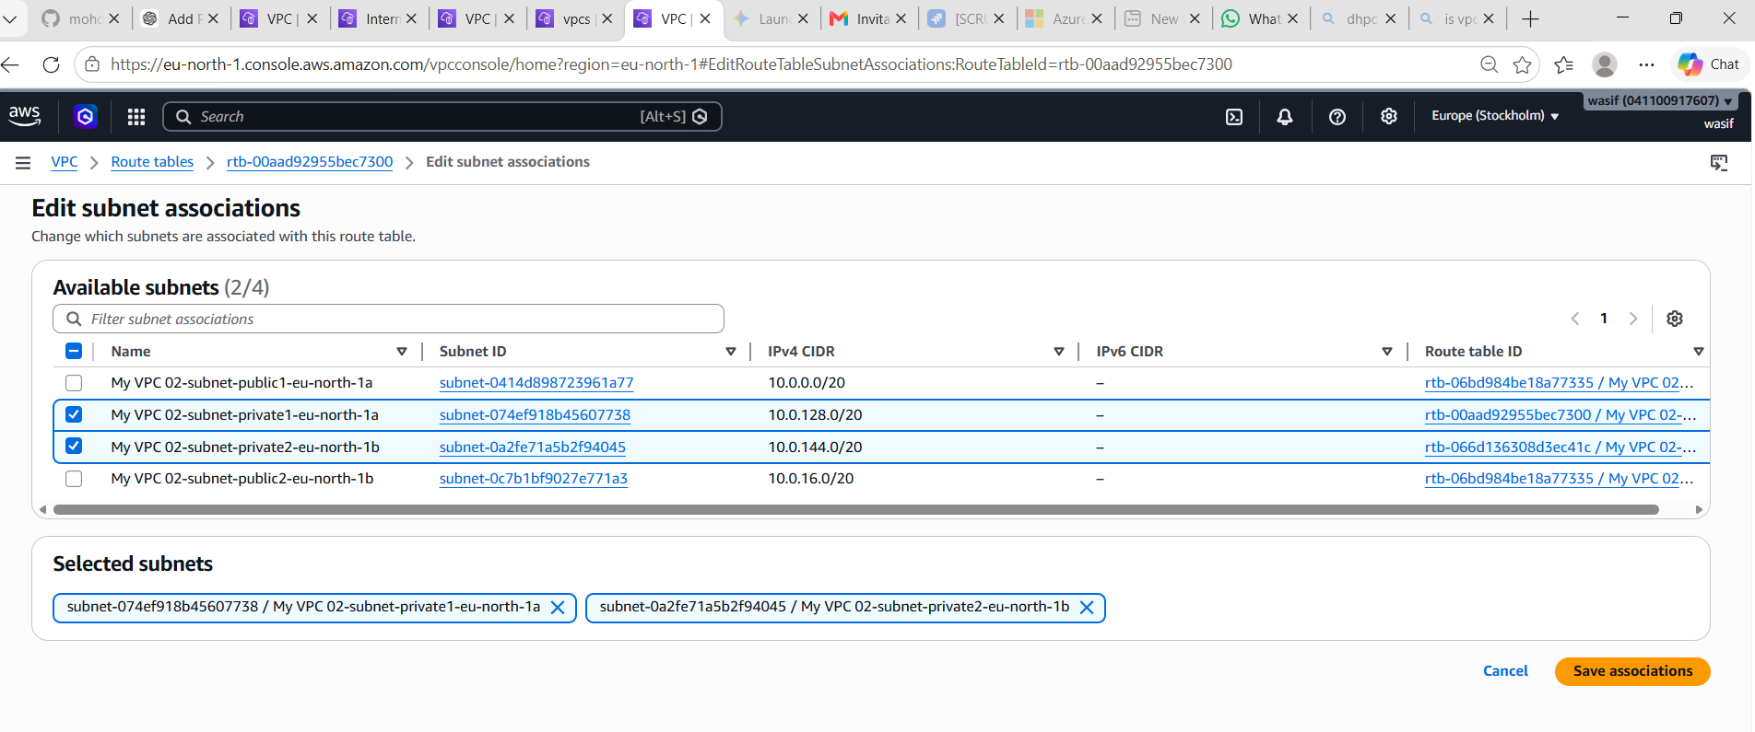

Result:
Both private subnets are now linked to the private route table and will follow its routing rules (no direct Internet Gateway access).

5. Add 2 public subnets in public route table.
step simple lines to add 2 public subnets to a public route table in AWS:
- Open AWS Management Console → go to VPC service.
- Click on Route Tables from the left panel.
- Select your Public Route Table.
- Go to the Subnet Associations tab.
- Click Edit subnet associations.
- Select your Public Subnet 1 and Public Subnet 2.
- Click Save associations.

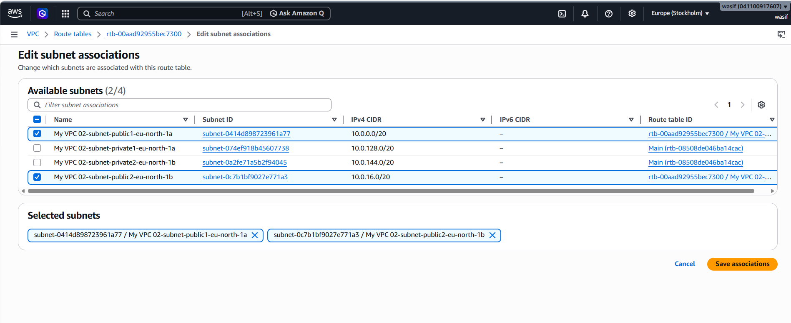

Result:
Both public subnets are now attached to the public route table and can access the internet (via Internet Gateway if configured).

6. Public route table will have the routes to internet and local.
Step 1: Check route table first
- Go to VPC → Route Tables
- Open your route table that you think is public
- Go to Routes tab
- Check if you see:
  - 0.0.0.0/0 → Internet Gateway (igw-xxxx)

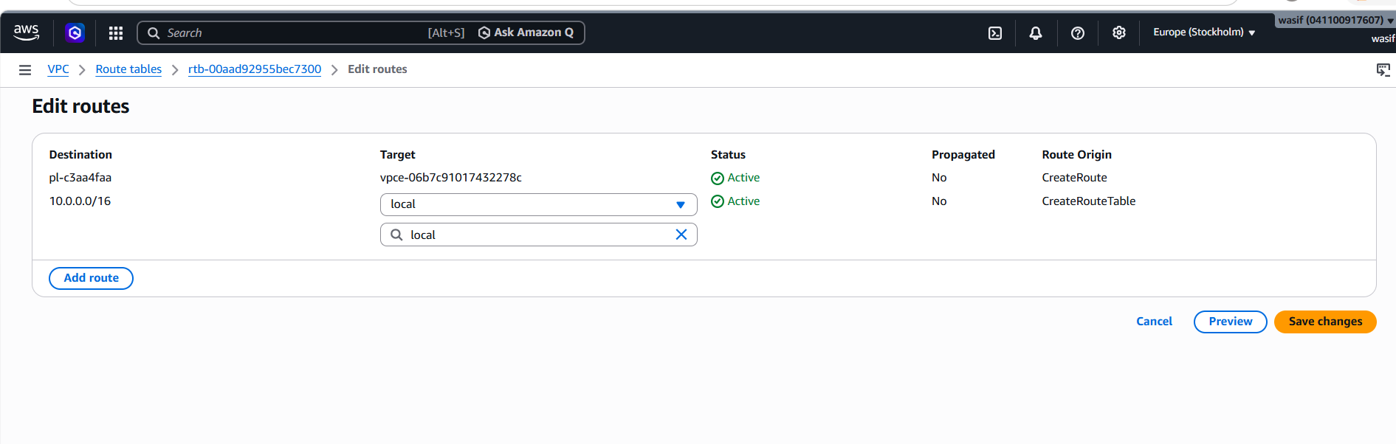

7. Create EC2 in public subnet with t2.micro and install PHP.

Step 1: Create VPC
- Create a VPC with CIDR 10.0.0.0/16
- This gives a private network in AWS for resources

🔹 Step 2: Create Internet Gateway
- Create an Internet Gateway (IGW)
- Attach it to your VPC
- IGW allows internet access to public subnets

🔹 Step 3: Create Public Subnet
- Create subnet like 10.0.1.0/24
- This subnet is used for public EC2 instances
- Enable auto-assign public IPv4 address

🔹 Step 4: Create Route Table (Public)
- Create a route table for public subnet
- Associate it with the VPC

🔹 Step 5: Add Routes (IMPORTANT FIX)
- Add route:
  - 10.0.0.0/16 → local (internal communication)
  - 0.0.0.0/0 → Internet Gateway (internet access)
👉 This step makes subnet truly PUBLIC

🔹 Step 6: Associate Subnet with Route Table
- Attach public subnet to PUBLIC route table
- Without this, subnet behaves like private subnet

🔹 Step 7: Launch EC2 Instance
- Choose Amazon Linux AMI
- Select instance type t2.micro
- Place EC2 inside PUBLIC subnet
- Enable auto-assign public IP
- Attach security group

🔹 Step 8: Configure Security Group
- Allow SSH (port 22) from 0.0.0.0/0
- Allow HTTP (port 80) for web access

🔹 Step 9: Connect using SSH
ssh -i "Linux-Learning.pem" ec2-user@<Public-IP>
Add route
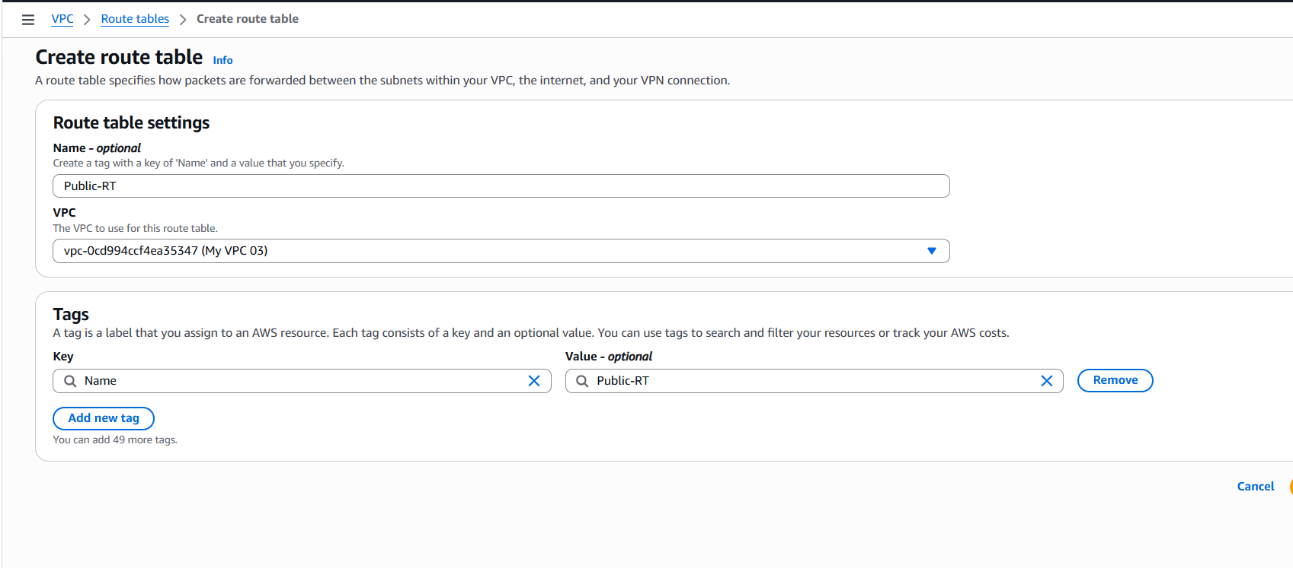

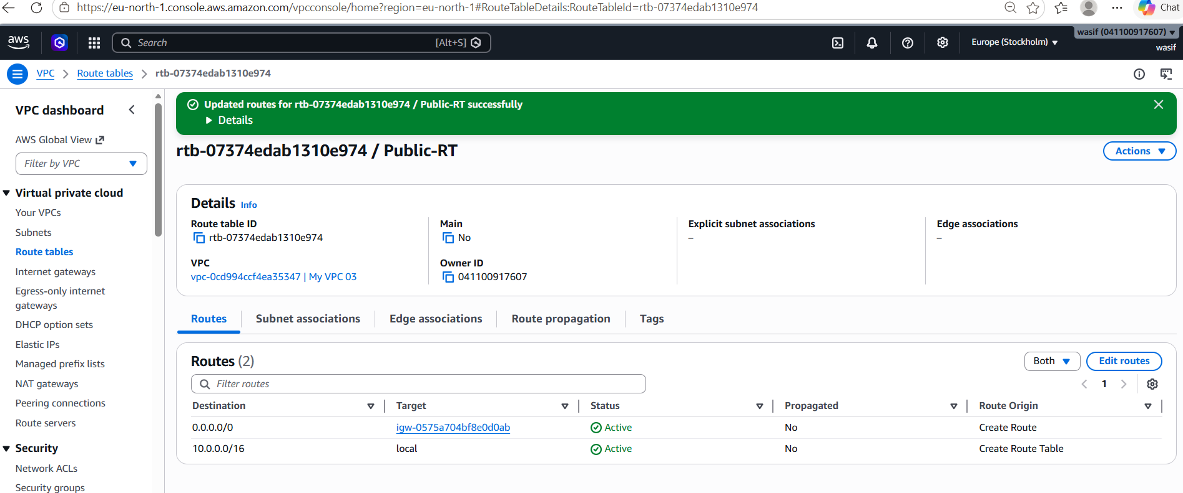
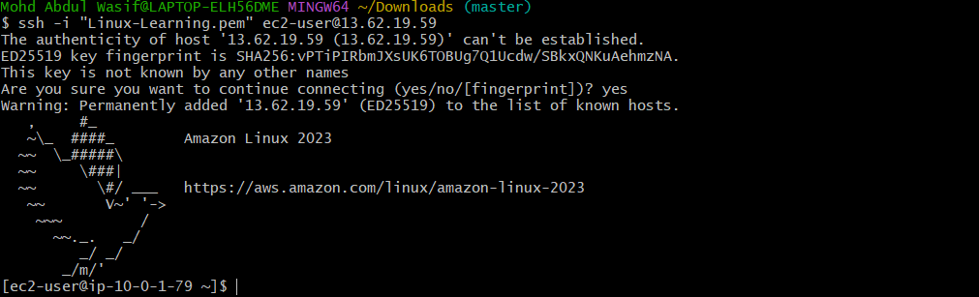

Step 10: Install PHP
sudo yum update -y
sudo yum install php -y
php -v

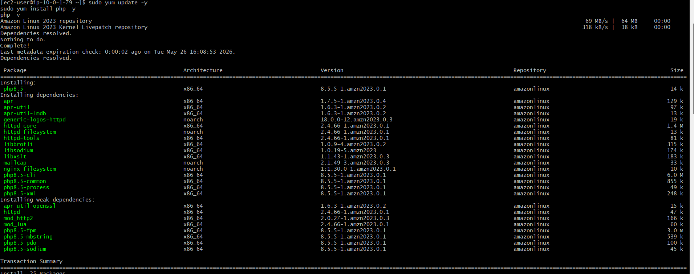
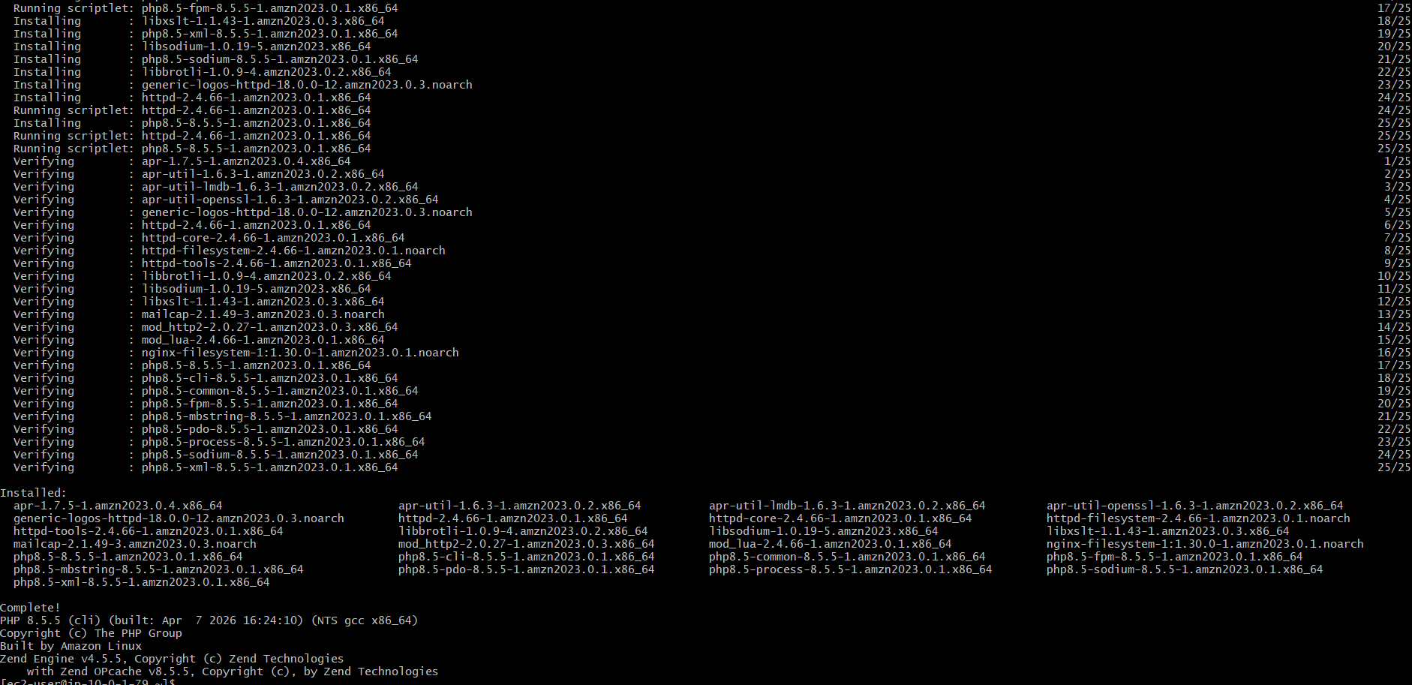

WHAT WE LEARNED
- A subnet is NOT public just by name
- A subnet becomes public ONLY when:
  - It has route to Internet Gateway
- SSH requires:
  - Public IP + IGW route + Security Group open port 22
- AWS networking depends on:
  - VPC → Subnet → Route Table → IGW → Security Group

🎯 FINAL RESULT
- VPC created successfully ✔
- Internet Gateway attached ✔
- Public subnet configured ✔
- Route table fixed ✔
- EC2 launched in public subnet ✔
- SSH access working ✔
- PHP installed successfully ✔

🏁 FINAL CONCLUSION
👉 SSH timeout happened due to missing Internet Gateway route in route table
👉 After fixing route table, EC2 becomes accessible from internet
👉 Proper VPC design is required for public EC2 access

8.Configure NAT gateway in public subnet and connect to private instance.
Steps:
- Exit Bastion and copy PEM file from laptop using scp -i Linux-Learning.pem Linux-Learning.pem ec2-user@<Bastion-IP>:~
- Login again to Bastion using ssh -i Linux-Learning.pem ec2-user@<Bastion-IP>
- Check PEM file in Bastion using ls command
- Set permissions using chmod 400 Linux-Learning.pem
- Connect to private EC2 using ssh -i Linux-Learning.pem ec2-user@<Private-IP>
- Verify connection by running whoami or hostname

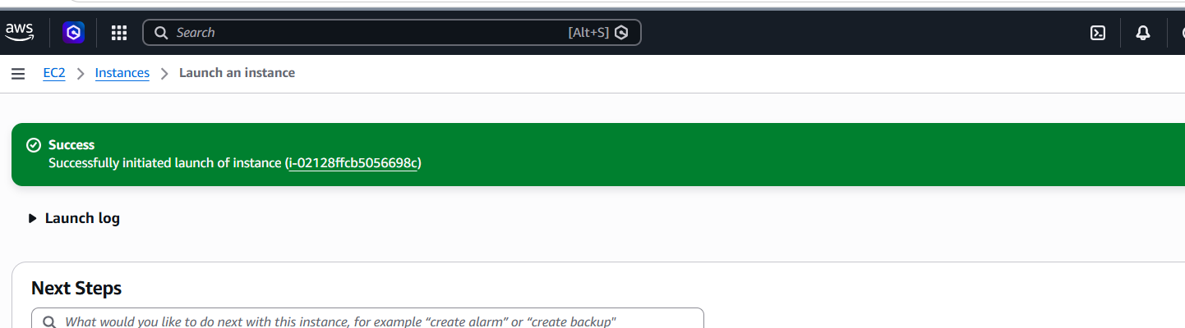

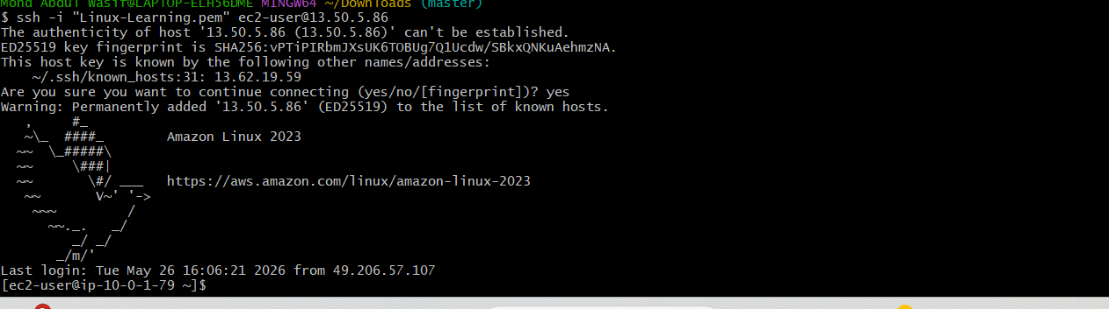

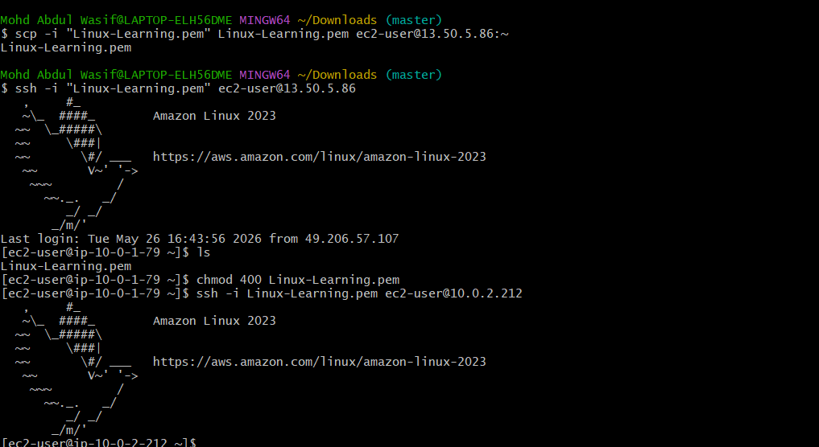

FINAL RESULT
After this:
- ✔ Bastion login works
- ✔ PEM copied successfully
- ✔ Private EC2 access works
- ✔ Secure architecture complete

🧠 WHAT YOU LEARNED
- Bastion does NOT have your local files automatically
- You must transfer PEM using scp
- Permission denied = missing key file
- Private EC2 requires internal VPC access

Laptop
↓ (scp key)
Bastion
↓ (ssh using key)
Private EC2

9. Install Apache Tomcat in private EC2 and deploy a sample app.

Steps:
- Launch two EC2 instances: one public (bastion) and one private (no public IP) in same VPC/subnets.
- SSH into bastion host from your laptop using .pem key.
- From bastion, SSH into private EC2 using its private IP.
- Install Java on private EC2: sudo yum install java-17-amazon-corretto -y.
- Download Tomcat: wget https://dlcdn.apache.org/tomcat/tomcat-10/v10.1.55/bin/apache-tomcat-10.1.55.tar.gz.
- Extract and move: tar -xvzf file && sudo mv apache-tomcat-10.1.55 /opt/tomcat.
- Start Tomcat: /opt/tomcat/bin/startup.sh and verify with ps -ef | grep tomcat.
- Copy sample app (WAR file) into /opt/tomcat/webapps/ using scp via bastion.
- Ensure Security Group allows 8080 only from bastion/private VPC CIDR (not public).
- Access app via bastion port-forwarding or ALB: http://<public-ip>:8080/app-name.

Login to public ip account
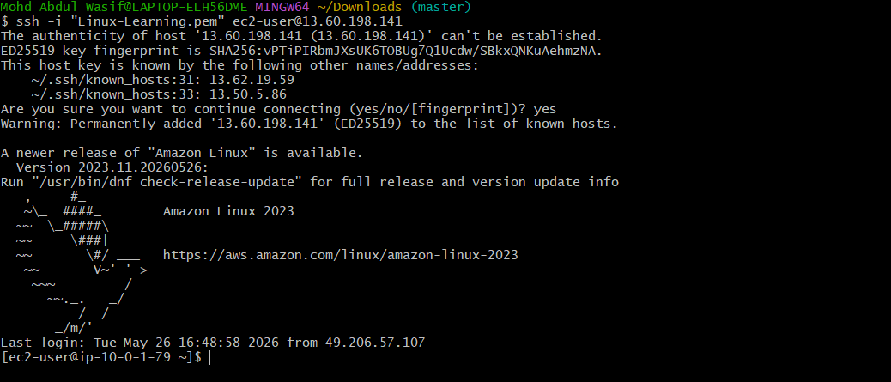

From public to login Private ip
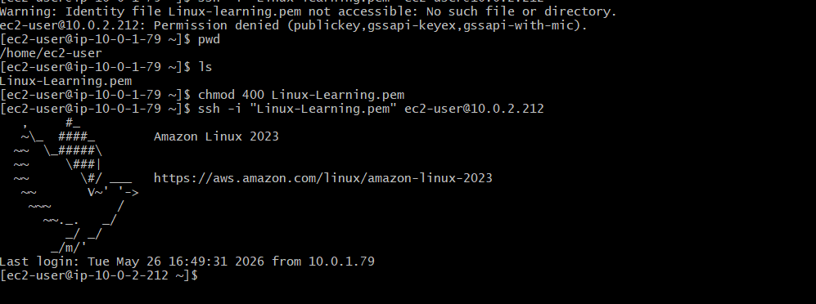

Installed Java 21
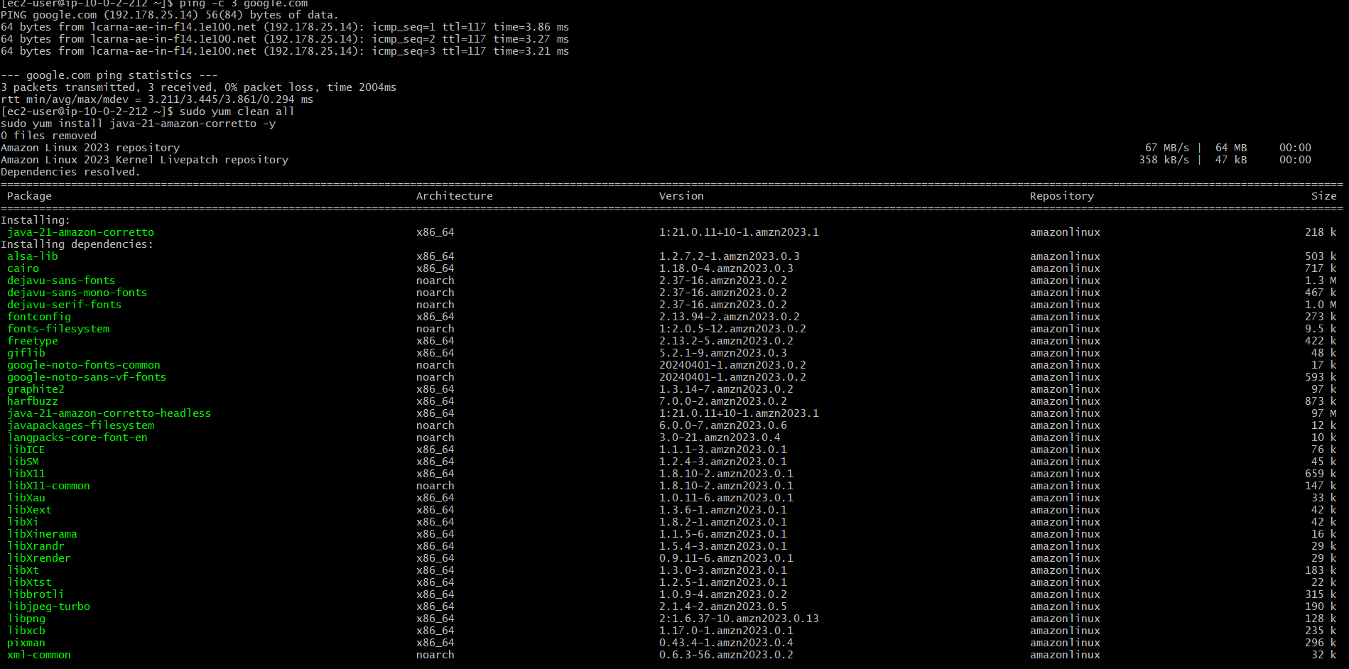

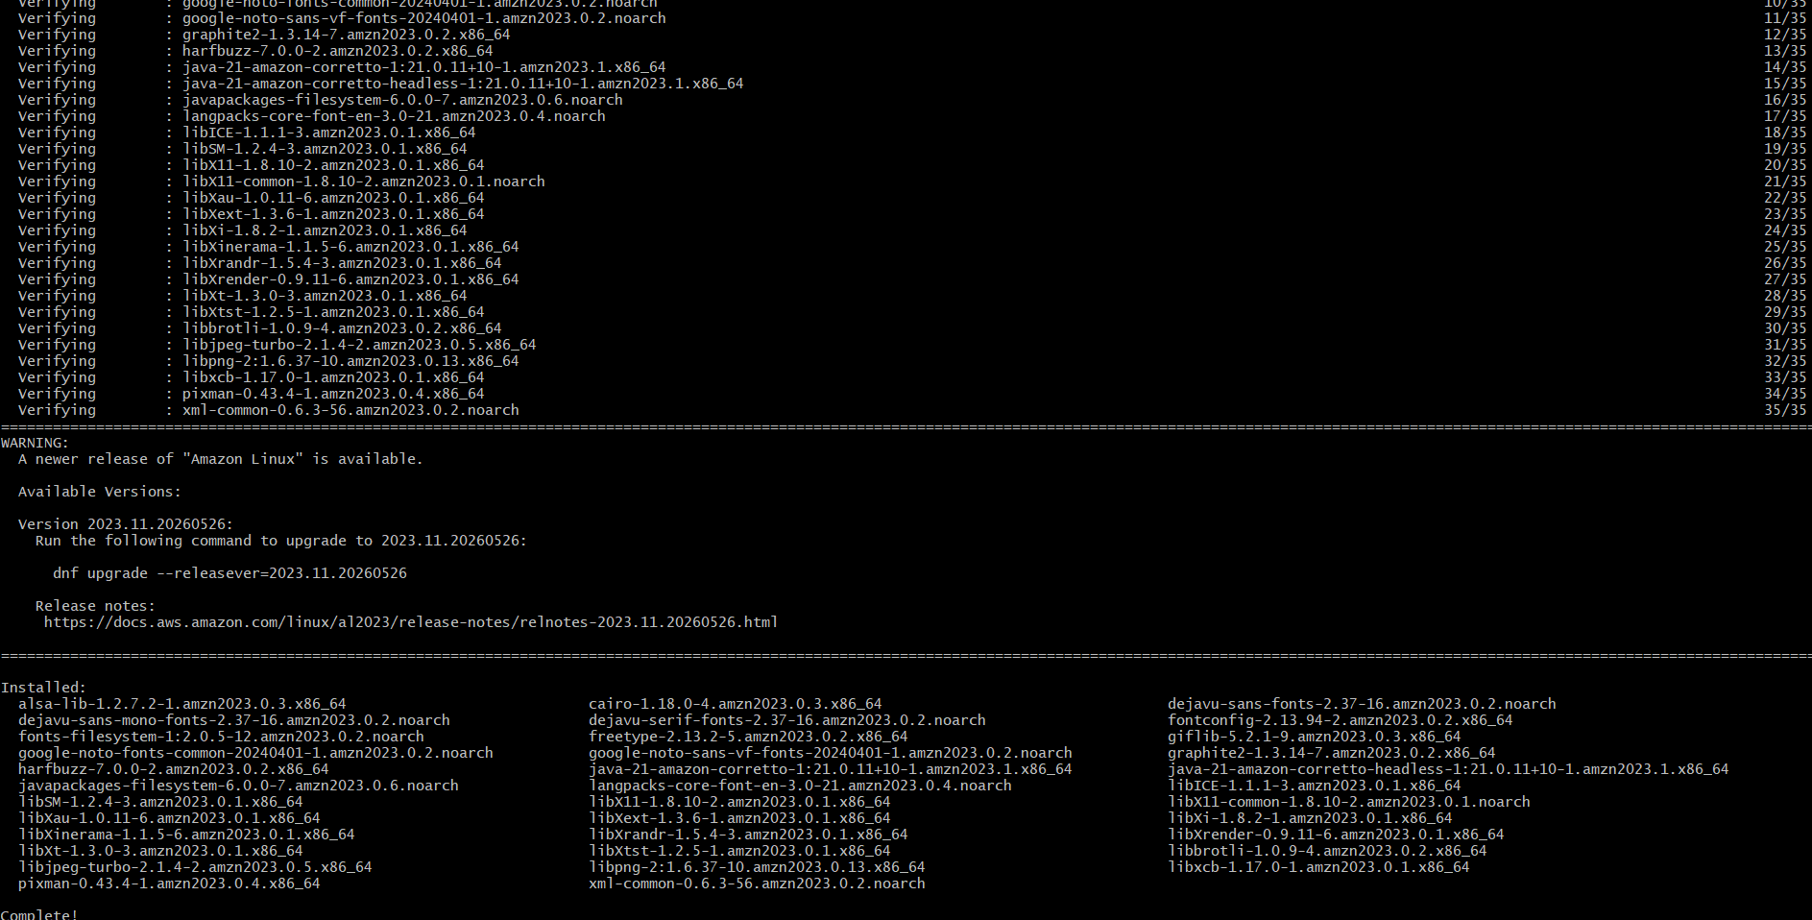

Installed tomcat
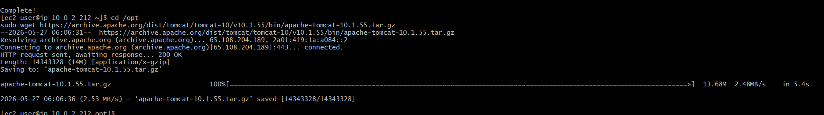

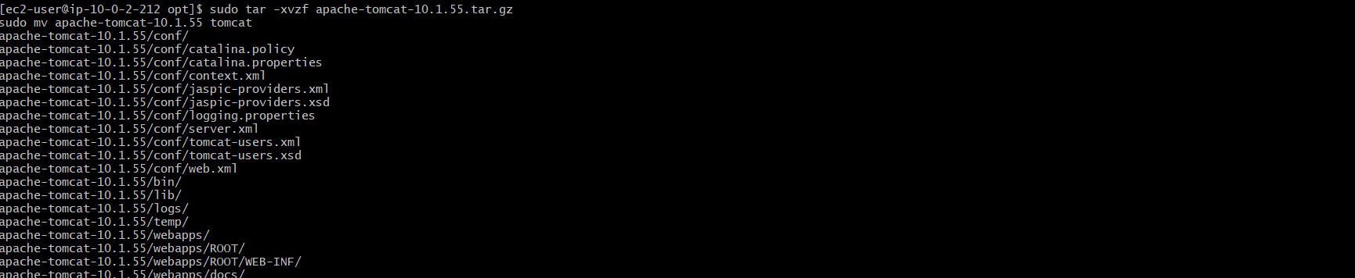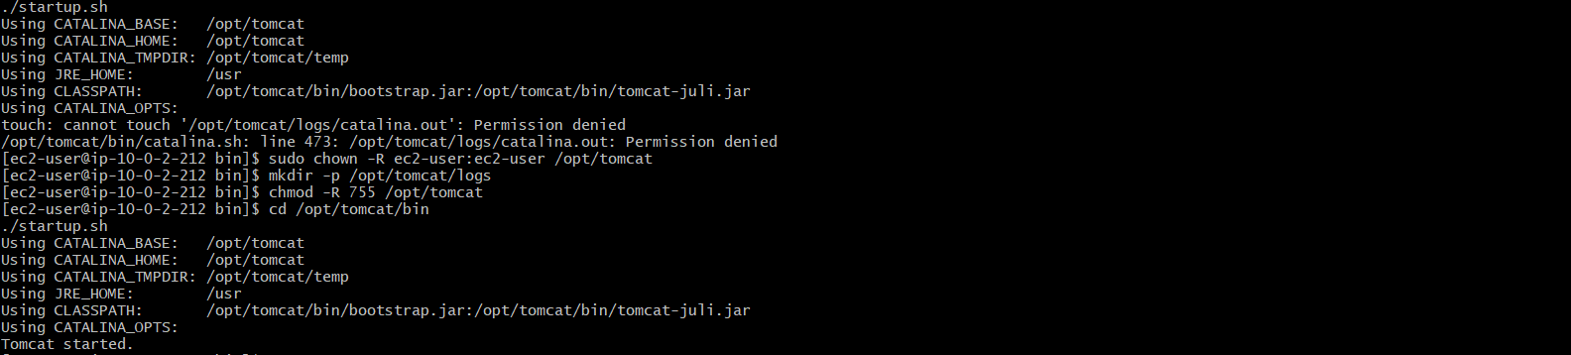
Tomcat working on port
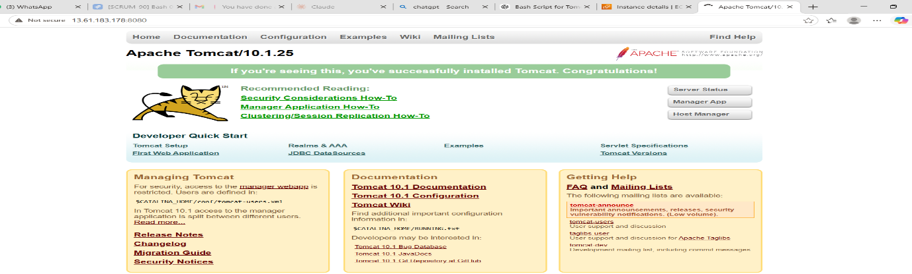

10.Configure VPC flow logs and store the logs in S3 and CloudWatch.

Steps:

VPC Flow Logs → CloudWatch + S3 (Steps)
- Go to AWS Console → VPC → Your VPC
- Click Flow Logs → Create flow log
- Select Resource type: VPC
- Choose Filter: All traffic
- Set Maximum aggregation interval: 1 minute
- For CloudWatch, select Send to CloudWatch Logs
- Create or select log group (e.g., vpc-flow-logs-group)
- Choose IAM role → Create new service role automatically
- Click Create flow log (CloudWatch logs start flowing)
- Again go to VPC → Create flow log (second time for S3)
- Select Send to Amazon S3 bucket
- Enter S3 ARN: arn:aws:s3:::your-bucket-name
- Choose AWS default log format
- Click Create flow log
- Verify logs in CloudWatch log streams + S3 bucket (AWSLogs folder)

Cloud watch
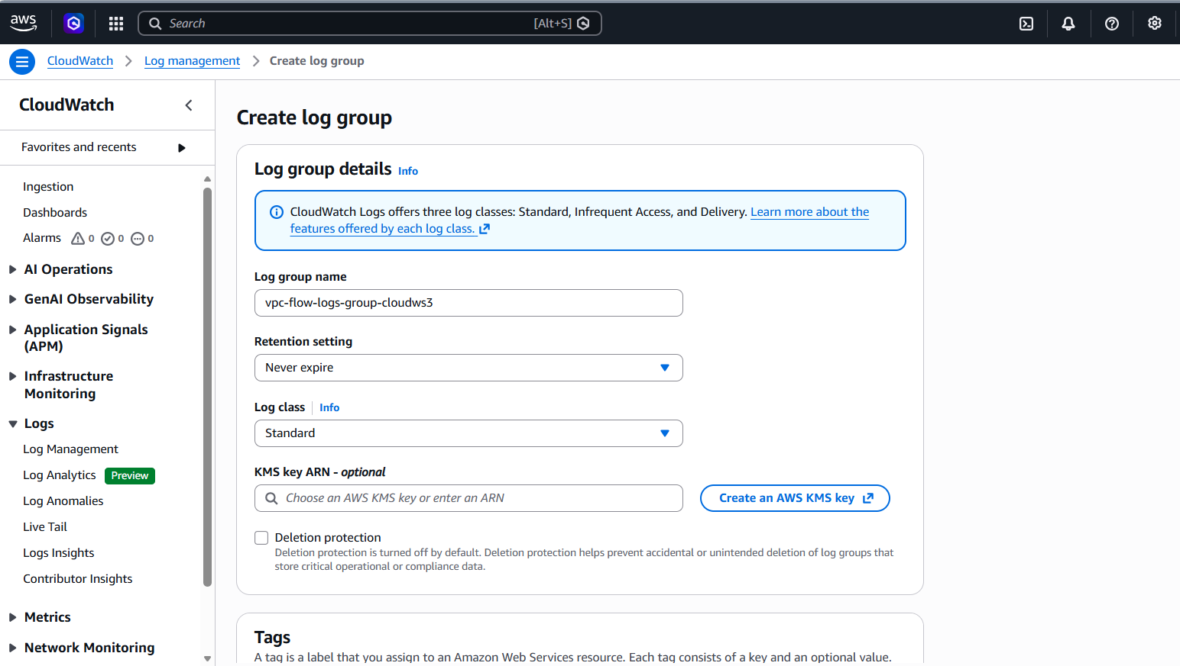

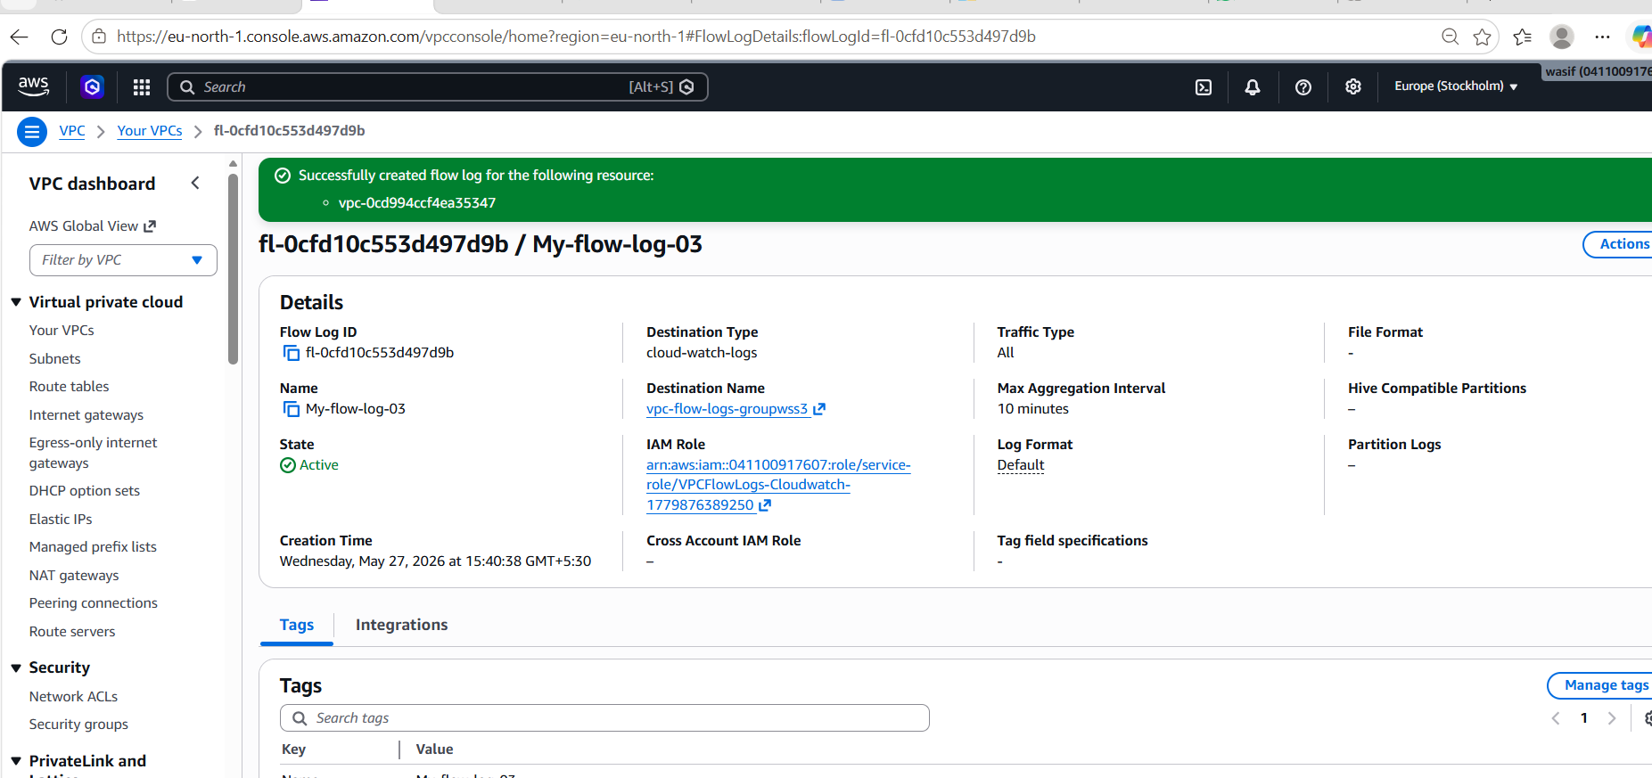
Cloudwatch bucket
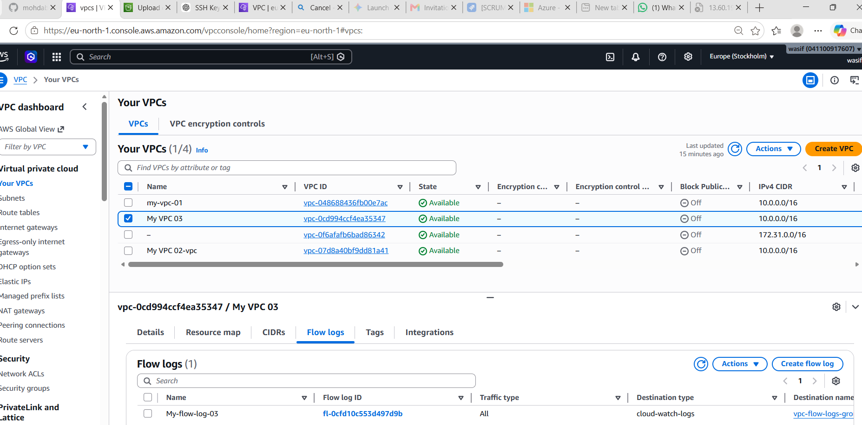

S3 bucket

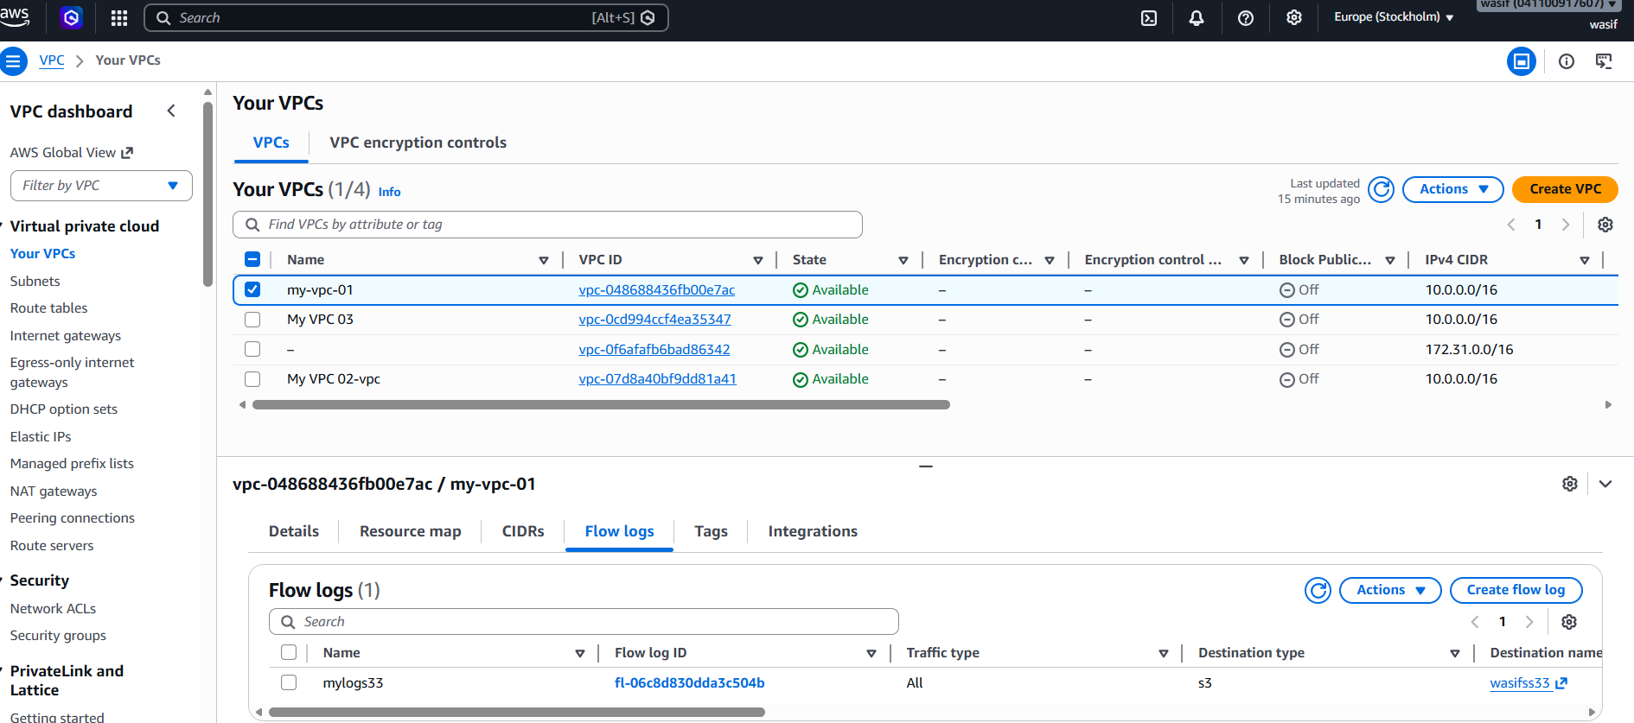

This project demonstrates the complete setup of a secure AWS VPC architecture with public and private subnets. It includes EC2 instance deployment, NAT Gateway configuration, and application hosting using PHP and Apache Tomcat. VPC Flow Logs are enabled to monitor network traffic and are stored in both Amazon CloudWatch and S3 for analysis. This setup ensures proper connectivity, security, and monitoring within the AWS cloud environment.

